Do you have COPD / Asthma or Diabetes?
Is your health condition affecting your mood? Do you feel Anxious, Worried, Low, Sad, Down?

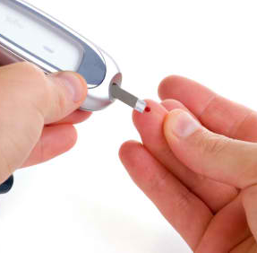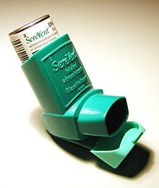
First Step is a free NHS service that provides effective talking therapies for adults with common mental health problems across South Cumbria.

Providing telephone, video or computerised treatment during COVID19 restrictions

Ask your GP or your specialist Practice Nurse to refer you.

Website: www.LSCFT.nhs.uk/First-Step

